TUV Institute Bugs
1-Name Of Company
- When the user generates any report, the Company Name field is always empty in all reports. (this Bug includes in all reports)
Flow Description
- The user logs in with admin credentials.
- Goes to the Exams section and clicks on All Exams.
- The system displays a list of all exams.
- The user selects an exam to generate a report by clicking on Exam Report.
- Then selects the desired report type.
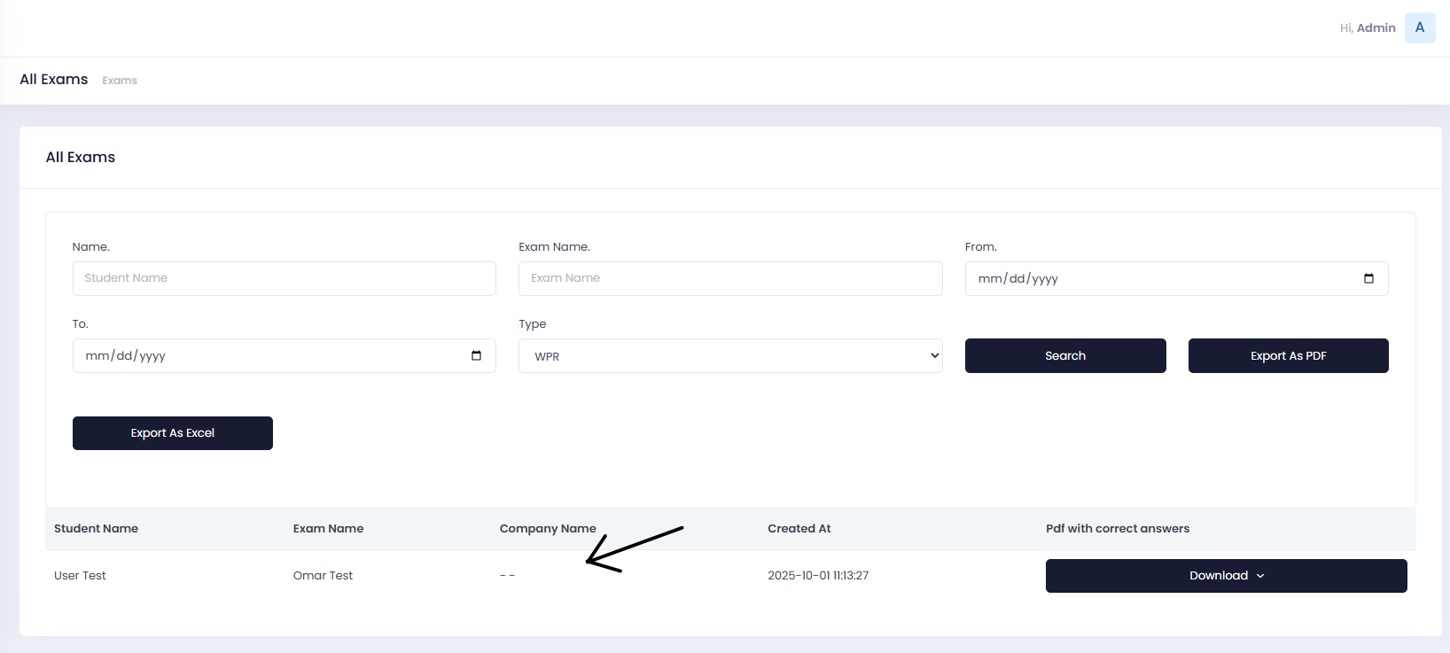
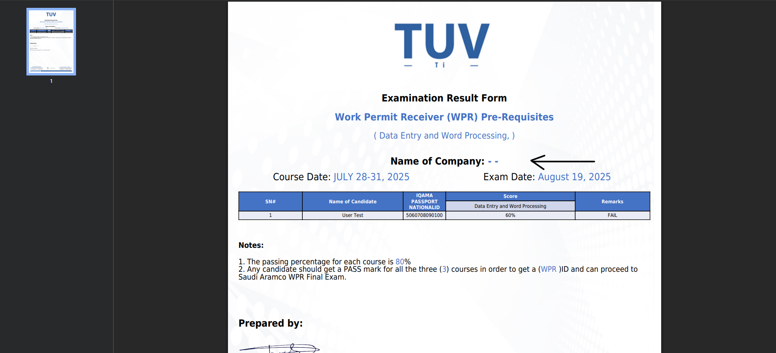
2- Course Date
- The Course Date field should be filled with the date when the user uploads users to courses from User Subscribed Courses Screen. (this Bug includes in all reports)
Flow Description
- The user logs in with admin credentials.
- Goes to the Exams section and clicks on All Exams.
- The system displays a list of all exams.
- The user selects an exam to generate a report by clicking on Exam Report.
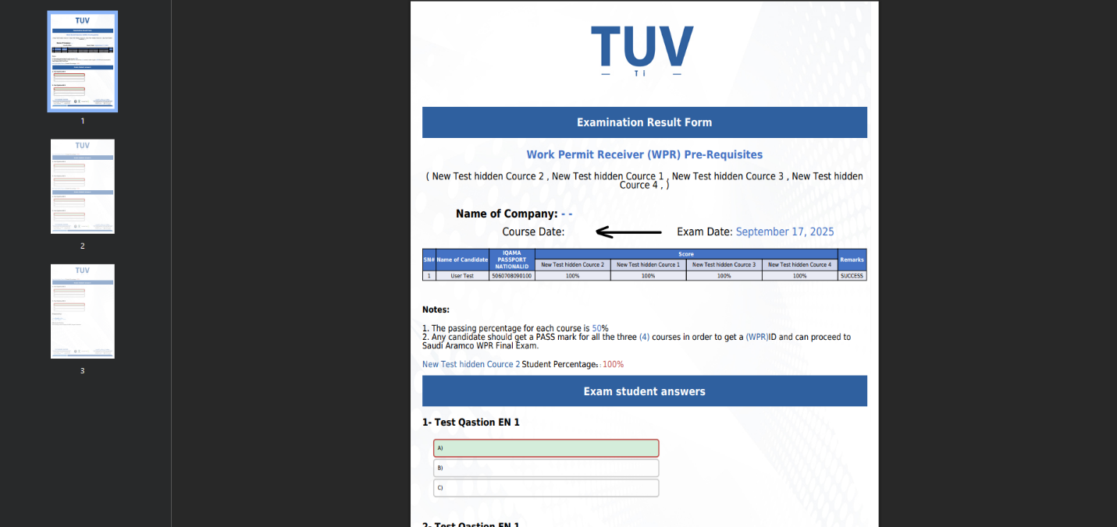
- Then selects the desired report type.
3- Move to Next Exam
- When the user finishes any exam, we need a button that allows the user to move to the next exam after submitting their answers.
Flow Description
- The user logs in with student credentials.
- Goes to the Exams page.
- The system displays a list of all exams.
- The user selects the exam they want to take.

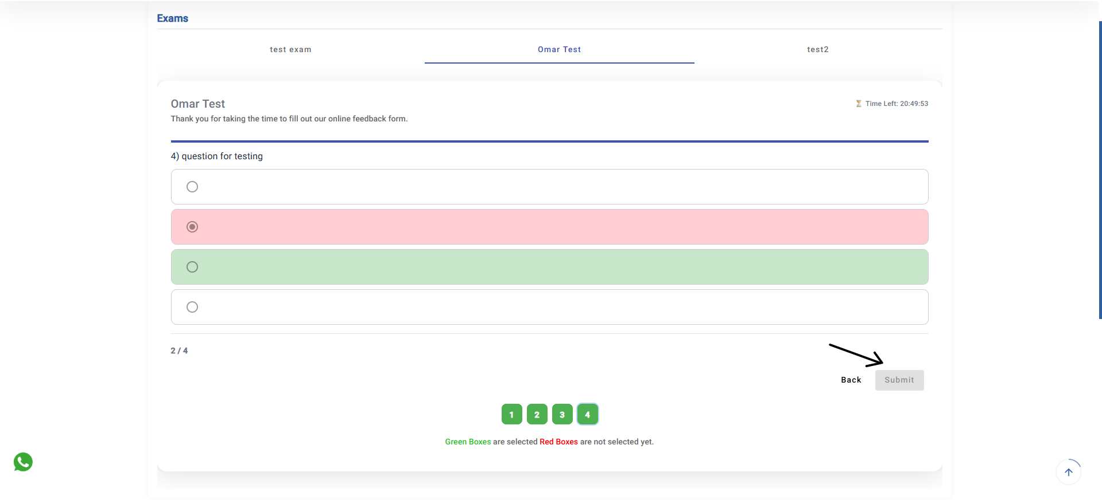
4- Frist Exam naming
- In any exam, the first exam always takes the Exam Name, which is incorrect. It should instead take the name of the Main Exam added by the admin.
Flow Description
- The user logs in with student credentials.
- Goes to the Exams page.
- The system displays a list of all exams.
- The user selects the exam they want to take.
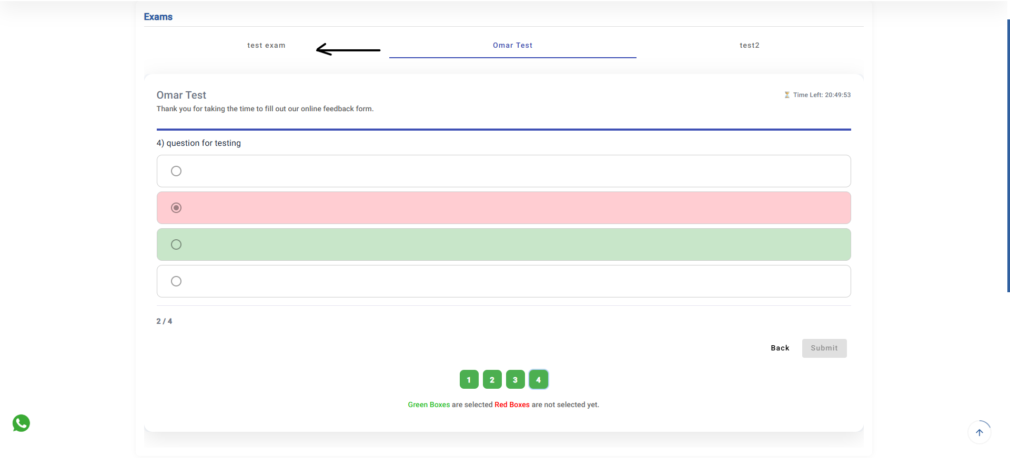

5- Ahmed Sultan’s signature
- When the admin user generates a (PDF with correct answers) WPR report, it ends with Hussain’s signature, which is incorrect. It should display Ahmed Sultan’s signature instead.
Flow Description
- The user logs in with admin credentials.
- Goes to the Exams section and clicks on All Exams.
- The system displays a list of all exams.
- The user selects an exam to generate a report by clicking on Exam Report.
- Then selects the desired report type.

- Wrong one
- Correct one
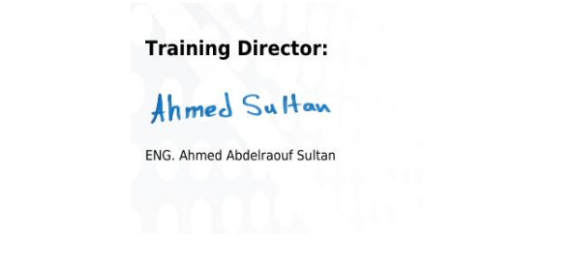
6- Osha PDF with Correct answer report
When the user generates the OSHA PDF with Correct Answers report, there is an error in the notes section. Also, the Name of Company field should display either the company name or the individual’s name.
Flow Description
- The user logs in with admin credentials.
- Goes to the Exams section and clicks on All Exams.
- The system displays a list of all exams.
- The user selects an exam to generate a report by clicking on Exam Report.
- Then selects the desired report type.

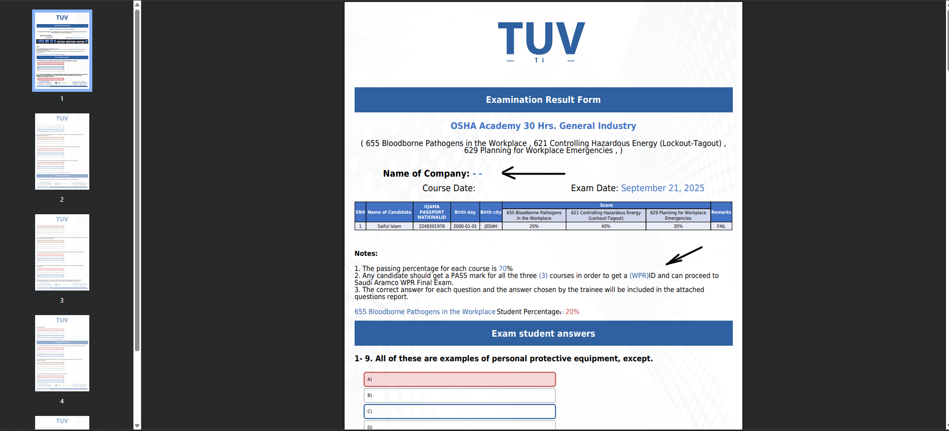

- Correct nots

